Foundation for Virtual and Augmented Reality Systems
Prof. Samit Bhattacharya
Department of Computer Science and Engineering
Indian Institute of Technology, Guwahati
Week – 01
Lecture – 04

Definitions

Hello and welcome to NPTEL course on foundation for virtual and augmented reality systems. We are going to start our lecture number three on definitions. Now in the previous two lectures we have covered few things namely we introduced some terms such as AR, MR, VR, XR. We also tried to get a very broad level understanding of these terms and learn the importance of these terms. why they are relevant, why we should know about them in terms of market size and need for skilled manpower. So we tried to establish that this emerging technology area is a very important one and it is for everybody's benefit if we know about them. And also in the previous lecture we covered some application domains and system categories. In this lecture what we are going to do is try to delve a little bit deeper into these terms in terms of more precise definitions of some of the terms that we have introduced earlier. So we'll be covering some definitions related to related to both VR and AR technologies and also we'll try to identify the defining characteristics of these technologies which help us to differentiate between them or to get a better understanding of them. So let us begin with virtual reality. Later on we will move to augmented reality. Now as you can notice VR or virtual reality comprises of two terms virtual and reality. Each of these terms is significant. Let us try to first understand what each of these terms are how they are defined. So when I say virtual what I refer to virtual is by definition by dictionary definition is being in essence or effect but not in fact.

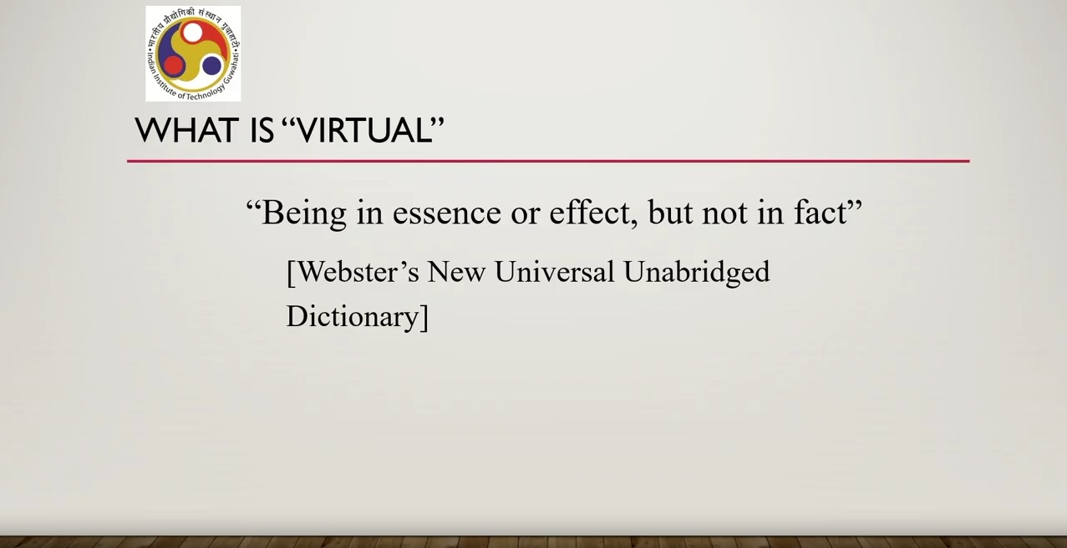
Of course, this is kind of a bit complicated definition being in essence or effect but not in fact something which is there but which we cannot actually attribute to any factual things. So this is according to Webster's new universal dictionary. Similarly, if we go by the dictionary definition of the term reality, what we get? The state or quality of being real. Now, this of course does not make anything clear. It's a kind of using the term to define itself. Another way of defining it is something that exists independently of ideas concerning it. that means being in fact whereas in virtual things are not being in fact. So if we try to relate the two virtual means something that is not there in fact whereas reality is something that is there in fact irrespective of whether any ideas concerning it are there or not. Another way of defining it is something that constitutes a real or actual thing as distinguished from something that is merely apparent. Now something that is merely apparent is of course virtual or unreal whereas something that constitutes a real or actual thing is reality.
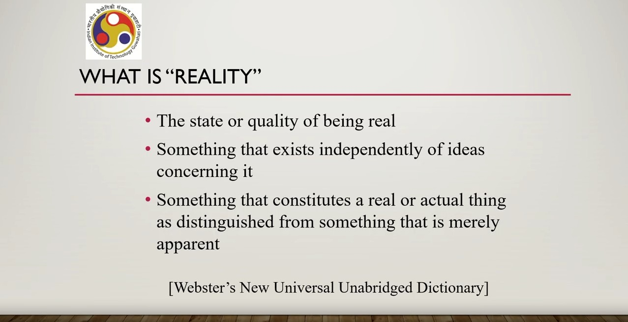
These are different ways to define the term reality. Now when we put them together we get virtual reality. So how to define this combination of terms virtual reality. Let us again go by dictionary definition. Miriam Webster dictionary which says a virtual reality is an artificial environment which is experienced through sensory stimuli as sights and sounds provided by a computer and in which one's actions partially determine what happens in the environment.
So there are several important things to note here. As per definition, an artificial environment which is experienced through sensory stimuli as sights and sounds. It can be other sensory stimuli as well. But sights and sounds play a primary role provided by a computer and in which one's actions partially determine what happens in the environment. So these are part of the dictionary definition of virtual reality. Now if we look at this definition we can find out three crucial aspects in the definition. artificial environment experienced through sensory stimuli provided by a computer and user actions partially determine what happens in the environment. Let us try to understand what these mean. Another thing to note here is that these aspects can help us characterize a VR system.

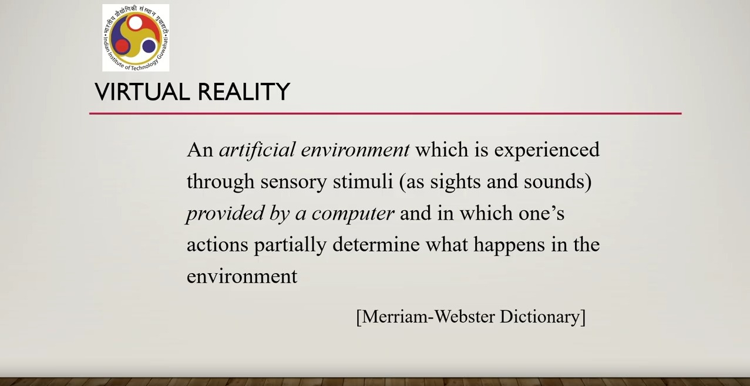

So whichever system is having these characteristics, they are VR systems or rather whichever system is having these aspects we can categorize them as VR systems. And in this way we will be able to identify VR system as well as distinguish VR systems from other systems. So other systems are not supposed to have these characteristics, these aspects vis-a-vis VR systems. Now let us try to understand these three characteristics in details. First characteristic what it says artificial or synthetic environment. So the definition indicates that a vr system must have an artificial environment. So one when we say artificial here we specifically refer to a computer generated environment. Thus a VR system is not a real environment and VR system which is an artificial environment must be populated with artificial objects. So in other words we have an artificial environment populated with artificial object which is one of the characteristics of a VR system. Now before I move to the second characteristics, let us try to understand this in a little bit more detail. So what we have said is specifically a VR environment is computer generated graphical representation of two things a real world or it can be an imaginary or fantastic world.
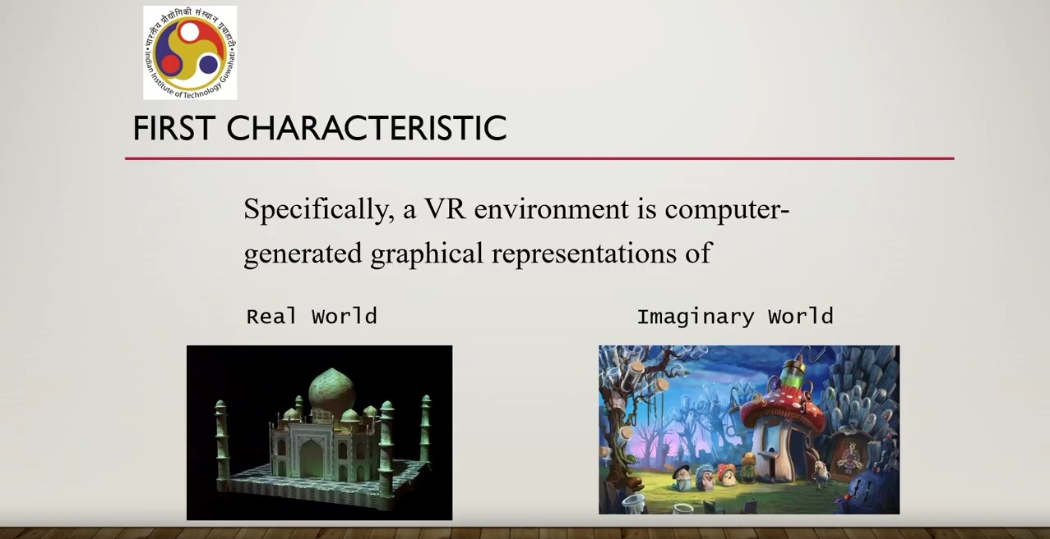
So whenever we say artificial environment immediately the image that comes to our mind is something that is fantastic imaginary rather than something resembling real world scenario. However in VR we can recreate real world using real world imagery videos something but in a computer. So that can still be counted as a VR system because that is not real time. It is created using real world imagery or video but it is not real time. So changes are not happening in real time. Say for example this image of this Taj Mahal. Now if we are using it in a virtual tour or in a virtual environment, we are actually using real world imagery, real world representation of a real world object but still it will be a virtual reality system because it represents a computer generated scenario maybe using real world. On the other hand, imaginary world representation is quite common, quite obvious. Whenever we say computer generated imagery, we are referring to mostly this type of scenarios, scenes or systems comprising of imaginary images, videos or scenes. Now let us move to our second characteristic that is sensory experience by computer generated stimuli.
So a VR system is supposed to provide to the user computer generated stimuli so that that environment can be experienced by the user. So the implication is the immersive experience of the artificial or synthetic environment using our sensory organs such as eyes, ears etc. So the system should be able to generate stimuli that stimulates our sensory organs to give us the immersive experience which is a hallmark of virtual reality system. So that is the second characteristics. So we should be able to sense whatever is provided or generated by the computer. Now the third characteristic is user actions partially determine what happens in the environment. What is the implication of this characteristic? It indicates that the VR systems must be interactive in nature. In other words, dynamic change in the virtual environment is happening or should happen based on user's actions.
So, user must be able to act. user must be able to do things in the environment so that the environment changes by changing objects by changing other things and so on. So that this is the third characteristics. Third characteristic that a VR system must be interactive. A user should be able to interact with the elements present in the environment just as we interact with the objects that surround us in our real world. In summary, what we can say is that there are three aspects of VR systems. Artificial environment that is synthetic graphical view of a real or imaginary world. Then it should be able to generate stimuli so that we are able to experience immersion using our sensory organs. And third is interaction that is dynamic change in the virtual environment based on users actions or rather inputs provided to the environment. So these three are the defining characteristics of any given VR system.
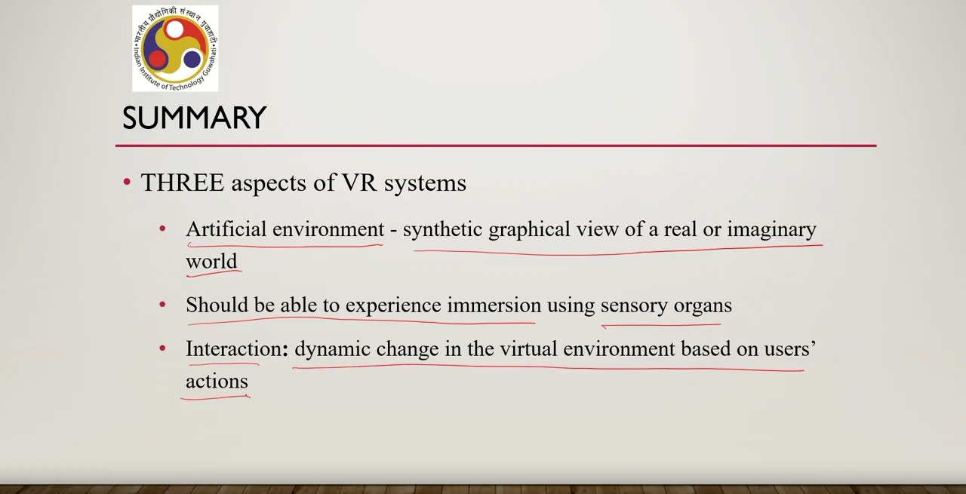
Now let us see how we can utilize this knowledge. We can utilize this knowledge by using these three as a way to identify whether a system is a VR system or not. How we can do that? It's very simple. We just check for the three characteristics. If the system satisfies all of these characteristics, then it is a VR system otherwise it is not. So even if one characteristic is not supported, we cannot call it a VR system. Let us see few examples. So I'll be playing few videos so that you are able to better comprehend the examples. So this is our first video. It is an example of a CAD or computer aided design system.
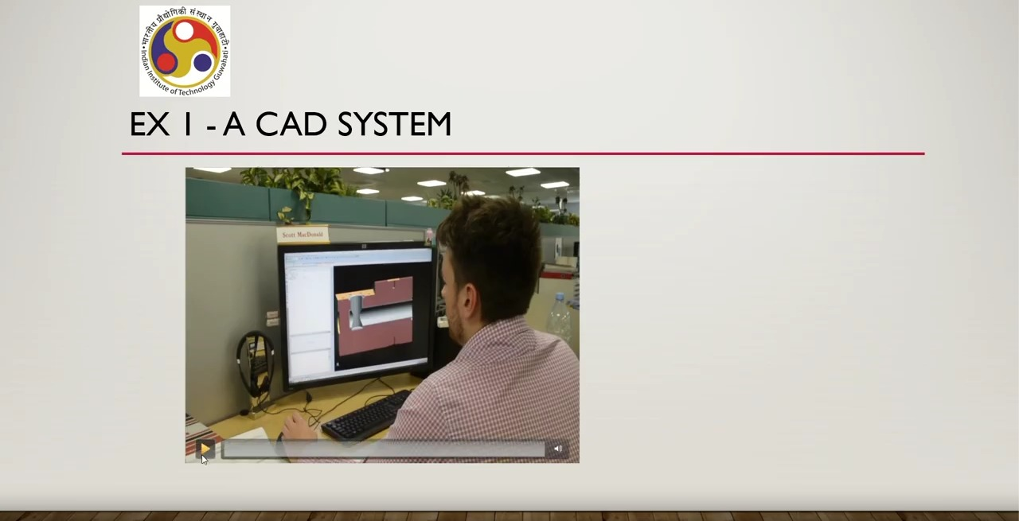
So what happened here as if I replay it you can see that there is a person sitting in front of a screen and there are certain things happening on the screen. User can interact with the screen with the content on the screen as you can see here in the video. that based on that interaction screen content is changing. Interaction mode is through mouse. the input device is mouse. Now that is the system. Now is it a VR system? Can I categorize it as a VR system? Rather than trying to directly answer it, let us try to do a characteristic check. Let us see which of the three characteristics it supports or do not support. If it supports all the three characteristics, then it must be a VR system. If it does not support at least one of those, then it cannot be called a VR system. So, let us first check. First thing is virtual environment. Is there a virtual environment present? Yes. There is a virtual environment. The screen content is virtual of course. Can I call it immersive environment? That is is it generating stimuli to stimulate all our sensory organs? No, it is not. it's only as computer screen our so we are able to see it but along with that we are able to see things in the real world surrounding the computer screen. So it is not an immersive environment or immersive experience. Is there interaction here? Of course, as we have seen there is interaction.
So among the three characteristics that is virtual environment, immersive experience through sensory organs and interaction. It supports two virtual environment and interaction whereas it does not support the immersive experience part. So clearly this is not a VR system. Now here a note of caution earlier we talked about non-emersive VR that is also kind of screen based 2D I mean this regular computer screen based experience and in this previous lecture I clarified why although it is regular screen based we are still calling it immersive experience that is purely from a psychological point of view however that psychological constraint is not applicable in this particular application of CAD design CAD system. Let us see one more video a video conferencing system.
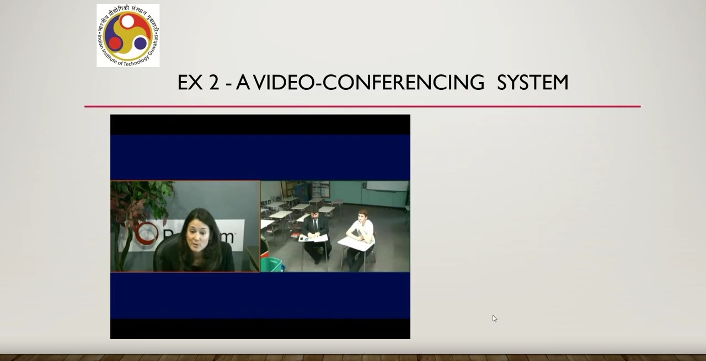
So the actual conversation is not important here. So I can skip it and we can come to the end of it. So is it a VR system? So here what is happening? Some people are sitting at different places on earth. They are connected through a video conferencing system. So in front of them they are screen. So they are seeing things on a screen. Now can I call it a virtual reality system? Let us again go for characteristics check and let us see whether they satisfy all the three characteristics. Virtual environment is it a virtual environment. It is not really a virtual environment because everything is happening in real time. Although we are seeing it on a screen but things are happening real time. So if at this moment something is changing at one place that is reflected immediately on the screen of others sitting at different places. So it is not really virtual. It is a real world environment being viewed through a screen in real time. So virtual environment the first characteristic is not there. Surprisingly of course the second one is also clear that immersive experience is not there. We are actually in the real world although only the screen is aiding our interaction in the real world rather than replacing it. So we are not getting any immersive experience here but it is interactive. So in this case in this particular example one of the three characteristics is satisfied whereas the other two are not satisfied. So clearly it is not a VR system. Let us see one more example that is a 3D movie. Nowadays it has become very popular. Most of the movies are 3D now. So what happens in a 3D movie? We are wearing a sort of 3D glass seeing things in 3D supposedly 3D sitting in an auditorium or a movie hall as shown in this small video.
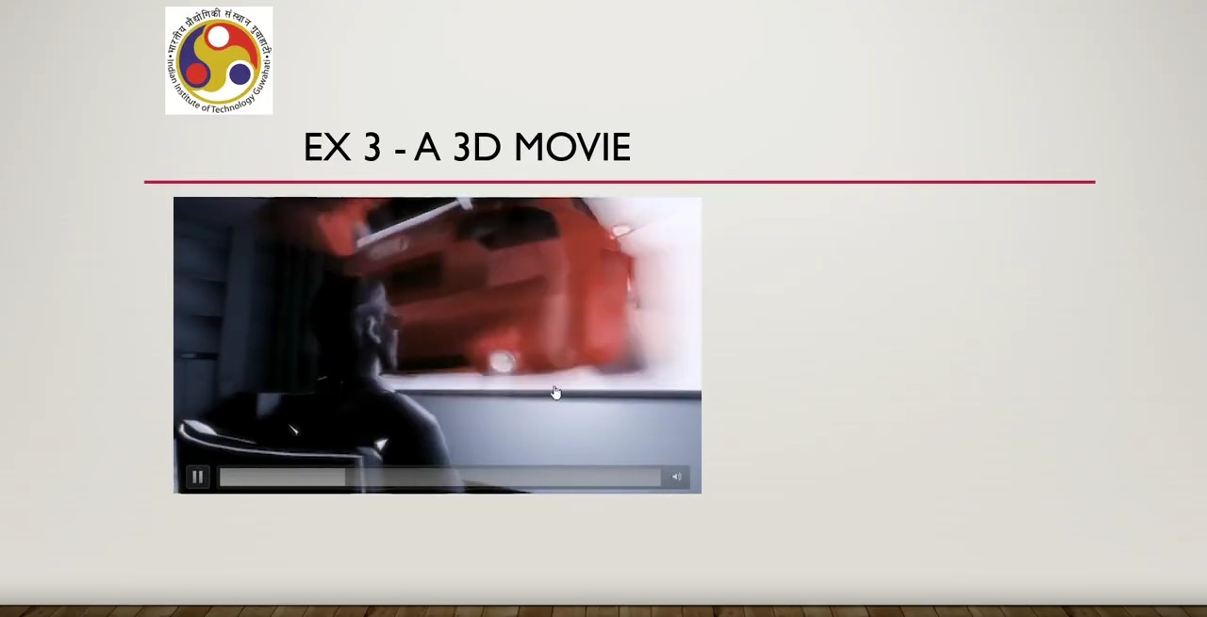
So here as you can see you are a user is supposed to wear a 3D glass. so is it a VR system? Again we'll go by the regular route that is checking the characteristics virtual environment. Yes, we are experiencing a virtual environment here. Clearly that is very obvious. Immersive experience. Yes, it is we can call it semi-immersive of course not fully immersive but still partly immersive because we are blocking our visual sense and also partly blocking our auditory sense and nowadays there are 7D or 8D movies also where other senses may also be activated to experience the content. So immersive experience partly yes virtual environment yes only thing that is not there is interaction. So here we are just watching we are unable to change anything that is being displayed in front of us.
So the third characteristic that is it must be interactive in nature is not supported since that is not supported. So even if the other two are supported, we can still say that it is not a VR system. So that is the conclusion that 3D movie experience is not a VR system. So now I hope that it has become clear what we can call a VR system and what we cannot call a VR system. The idea is very simple. We have three characteristic of a VR system. We just need to check against those characteristics and then based on that we need to conclude whether something is a VR system or not. So in summary what we have learned in this lecture in this part of the lecture is that we have learned def definitions of VR that is what is virtual reality and based on the definition we have identified three characteristics namely artificial environment immersive experience that is experienced through our sensory organs and interactivity. Based on these characteristics we can identify whether something is a VR system or not. In the next part of this lecture we are going to talk about augmented reality namely the definition of augmented reality characteristics of augmented reality augmented reality as well as the differences between AR and VR systems. So with that we come to the end of this part of the lecture. I hope you have understood the concept, you have enjoyed it and looking forward to see you again in the next part of the lecture. Goodbye. Thank you and happy learning.

